In Matthew 17:20 Jesus tells us, “if you have faith like a grain of mustard seed, you will say to this mountain, ‘Move from here to there,’ and it will move, and nothing will be impossible for you.”

Now, I don’t really want to talk about if you have enough faith to move a mountain or not. I don’t want to talk about whether or not we could actually move that mountain. We can get into that another time. What I want to talk about is our journey climbing the mountain.

In John 16:33 we read “I have said these things to you, that in me you may have peace. In the world you will have tribulation. But take heart; I have overcome the world.”

There it is in simple words from Jesus Himself, we will have tribulation in this life. In other words, we are going to struggle, we are going to fight, and yes we are even going to fall down sometimes and slide down the hill.

But here is the problem, our image of this mountain we are climbing. If you ask most people to draw a simple mountain they will give you this

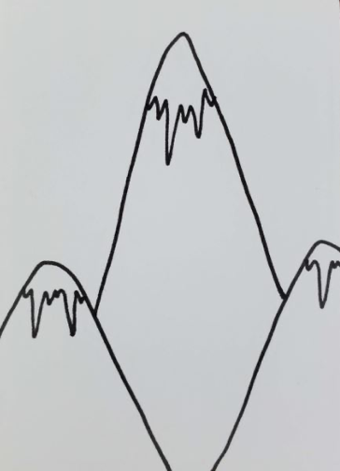

And what is the problem with this image? It is not realistic at all. It makes it appear that life is a steep climb, a hard climb, maybe even an impossible climb. And what happens when we look at something that is clearly impossible? We don’t even start. We look at this mountain and think, “I can’t climb that, will likely fall and never make it to the top.” We then back this entire thought up with another image that looks like this one and think, yep that is life.



But the truth is that this image of a mountain that we have is not God’s view of the mountain we are climbing. There are just too many flaws in this image. First of all, the mountain of Life that God gave us is not a straight climb. It has many peaks and valleys along the way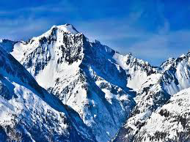. The image of the mountain that God has is simply more like this. It is full of hills of all kinds of inclines. It has plateaus and valleys. And that is because the life that God has for you will not always be hard. Yes, there will be hard days, some grueling days that seem to hard to handle. And there will even be days where it is all downhill and you can just coast. Of course there will also be days that are the plateaus of the mountain where it will not be either hard or easy, it will just be a day. We’ve all had all of these days at some point in our life.

But now I want to share a little secret with you that you may or may not know. You never fall back down this mountain you are climbing. Sure, it may seem that way sometimes. We often feel like we are taking one step forward and two steps back. But that just isn’t true. See, God has is on a journey, each and everyone of us has a different journey. And we are all striving everyday to get to the end of this journey.

Of course, most of us start out this journey as unsaved. We do things we are not proud of and we feel like we are continually falling back down the hill. But the truth is we are always making progress. Most of us trudged on as unbelievers for a time until we hit “our” rock bottom. That moment when we realize we need Christ and cannot take another step without Him. We see this;

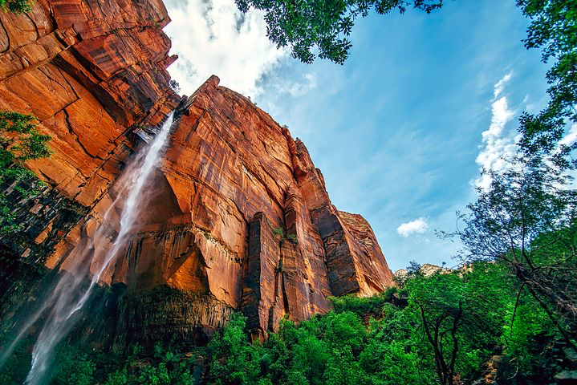For everyone of us this rock bottom is different. It may be as simple as being lonely, it may be as complex as loosing everything. A friend of mine found his rock bottom in a prison cell getting divorce papers served on him. Whatever the case may be we all get to our own rock bottom and turn to Jesus.

At this point we continue on our climb and we continue to make progress. Even when we fall down and we feel like we have slid down the hill backwards we are really sliding forward. The reason that I say that is because everything we’ve been through in life is what makes us who we are today. We learn from the mistakes we made. Sometimes we even make the same mistake several times but each time we learn something. And while we are learning something God is busy creating something, your testimony. Who you are today was created by everything you’ve been through in life. So when you fall down into a valley you are still making progress towards the top of that mountain.

And just what is at the top of the mountain? It is not some sharp peak. It is a massive plateau known as heaven. That is where this journey is headed and I know that as each one of us climbs the mountain of life we will have our testimonies. Some of our testimonies will cross paths as we help each other up this mountain and through some of the valleys. But just keep in mind that all those things in your past, even the things you are not proud of or are even ashamed of make up who you are today and when you look at that you will find an amazing person whom God is forming to His image.

I look forward to seeing all of you on this climb and thank those who have helped me along the way and those who will help me as I continue to climb towards heaven. God bless.